**GitHub Action**

Work Flow:



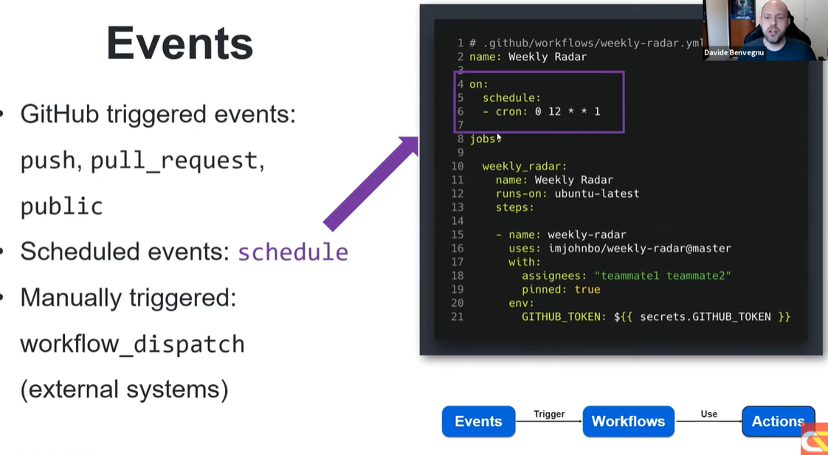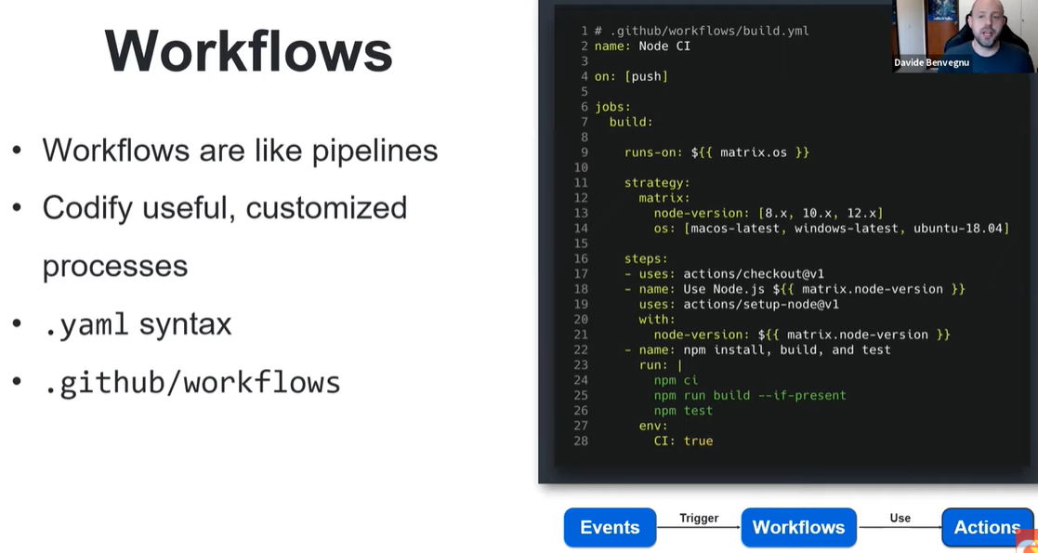

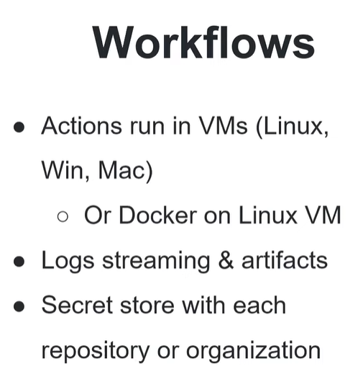

**Type of Action:**

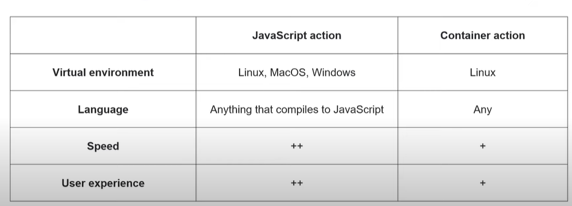

In azure DevOps there is stages and in github action it is job

* Make new Organization in Github

**Now generate secret:**

* In azure portal run following command

**az ad sp create-for-rbac --name "githubactionuser" --role contributor --scopes /subscriptions/af173fdc-9c6c-4fa7-bab2-69d025b4142a/resourceGroups/Demo --sdk-auth**

**it will give you secret**

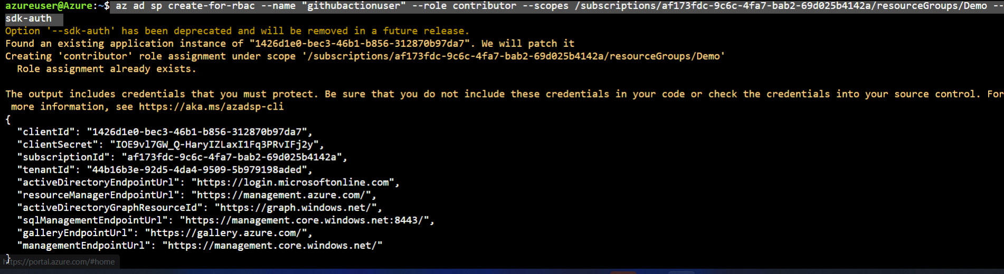

* Go to setting in github
* Go to secret
* Add it to secret

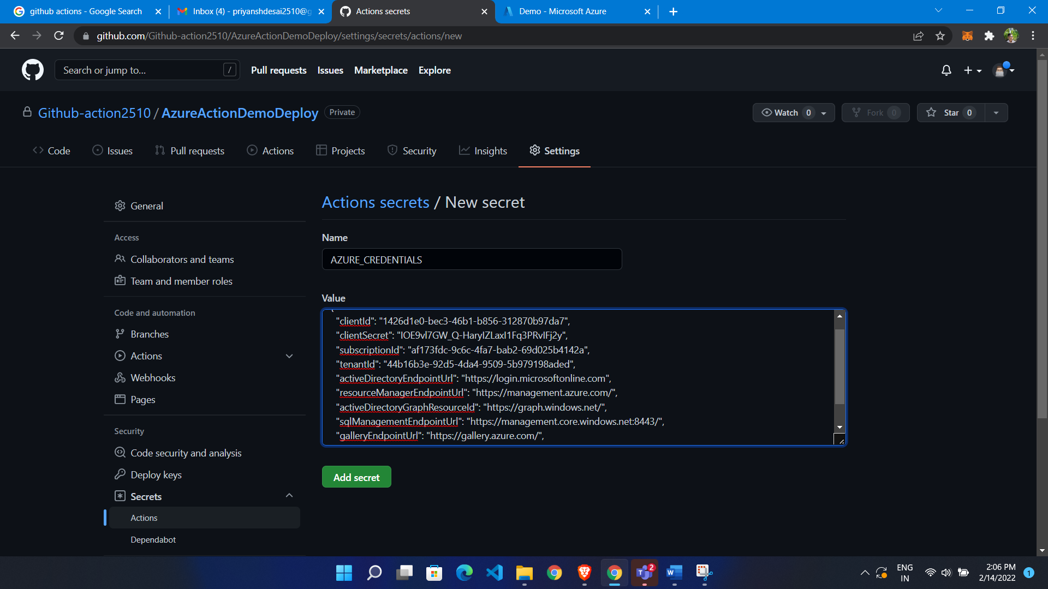

* Now Go to git
* Click on action
* Click setup work flow

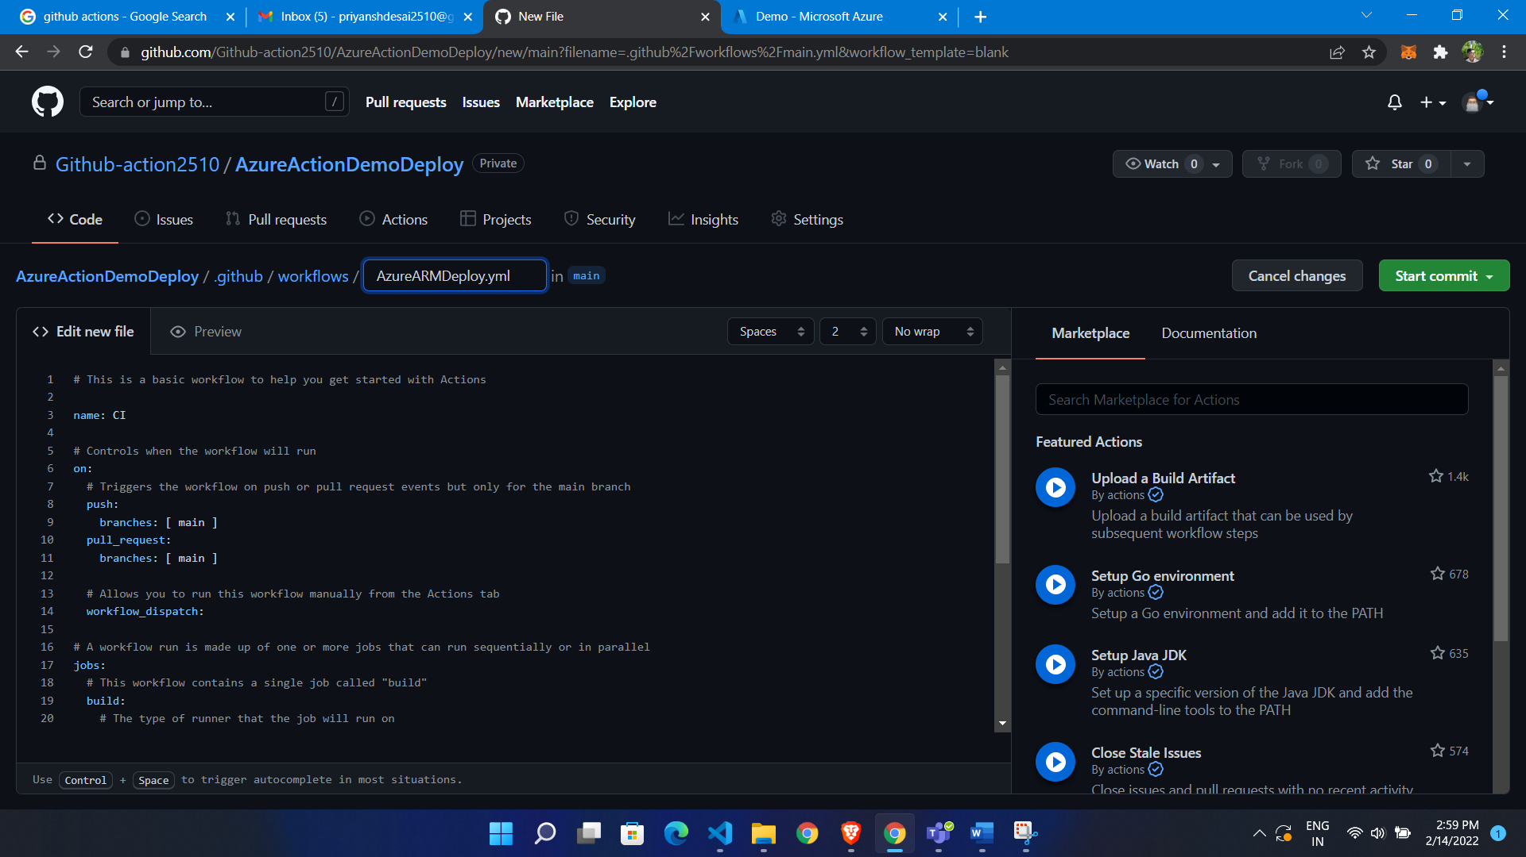

YAML file for deployment:

|  |
| --- |
| on: [push]  name: AzureARMDeploy  jobs:    Deploy:      runs-on: ubuntu-latest      steps:      - name: Login to Azure        uses: azure/login@v1        with:          creds: ${{ secrets.AZURE_CREDENTIALS }}        - name: Checkout source code        uses: actions/checkout@v2      - name: Deploy ARM template        uses: azure/CLI@v1        with:          inlineScript: |            az deployment group create \            --name StorageAccountDeployment \            --resource-group savdevgithubdeploy \            --template-file armTemplate/storageacc.json \            --parameters storageAccountType=Standard_GRS |

ARM template for Storage account

|  |
| --- |
| {      "$schema": "https://schema.management.azure.com/schemas/2019-04-01/deploymentTemplate.json#",      "contentVersion": "1.0.0.0",      "parameters": {        "storageAccountType": {          "type": "string",          "defaultValue": "Standard_LRS",          "allowedValues": [            "Standard_LRS",            "Standard_GRS",            "Standard_ZRS",            "Premium_LRS"          ],          "metadata": {            "description": "Storage Account Type"          }        },  //location        "location": {          "type": "string",          "defaultValue": "[resourceGroup().location]",          "metadata": {            "description": "Location for all resources."          }        }      },      "variables": {        "storageAccountName": "[concat(replace(toLower(resourceGroup().name),'-',''), 'stdsa')]"      },      "resources": [        {          "type": "Microsoft.Storage/storageAccounts",          "apiVersion": "2019-04-01",          "name": "[variables('storageAccountName')]",          "location": "[parameters('location')]",          "sku": {            "name": "[parameters('storageAccountType')]"          },          "kind": "StorageV2",          "properties": {}        }      ],      "outputs": {        "storageAccountName": {          "type": "string",          "value": "[variables('storageAccountName')]"        }      }    } |

**Now commit code to github**

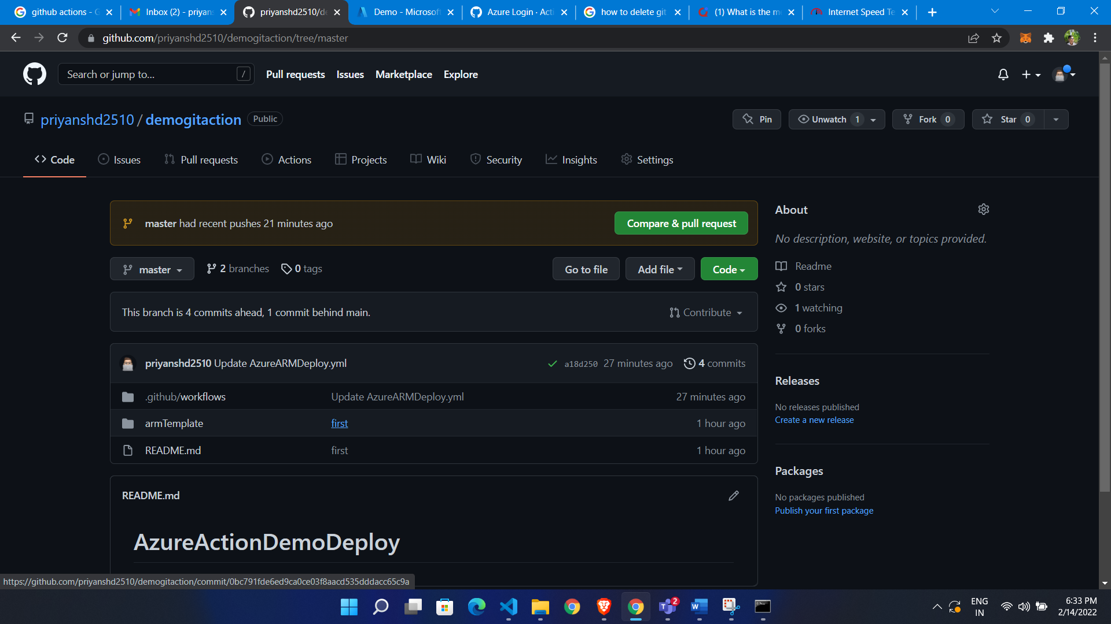

* **Go to action**
* **Where we find our build run**

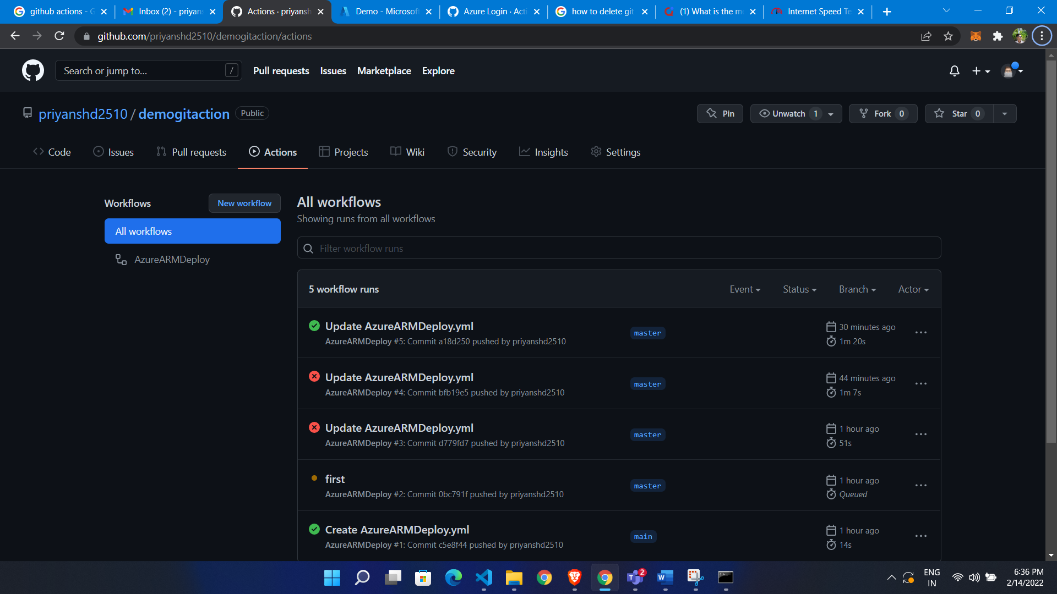

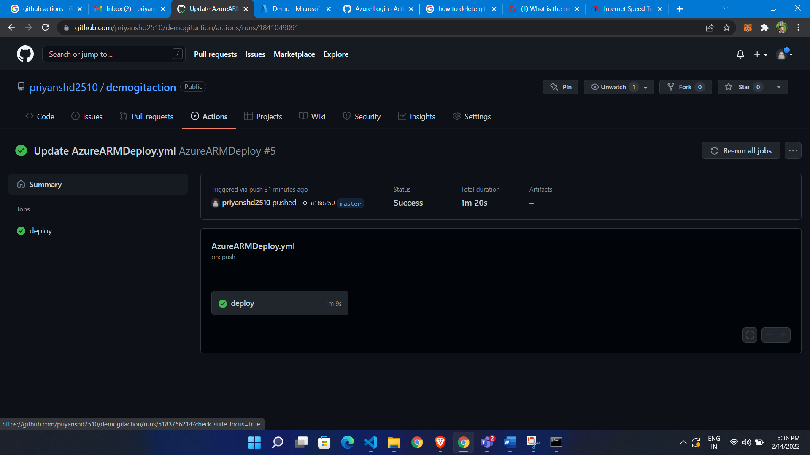

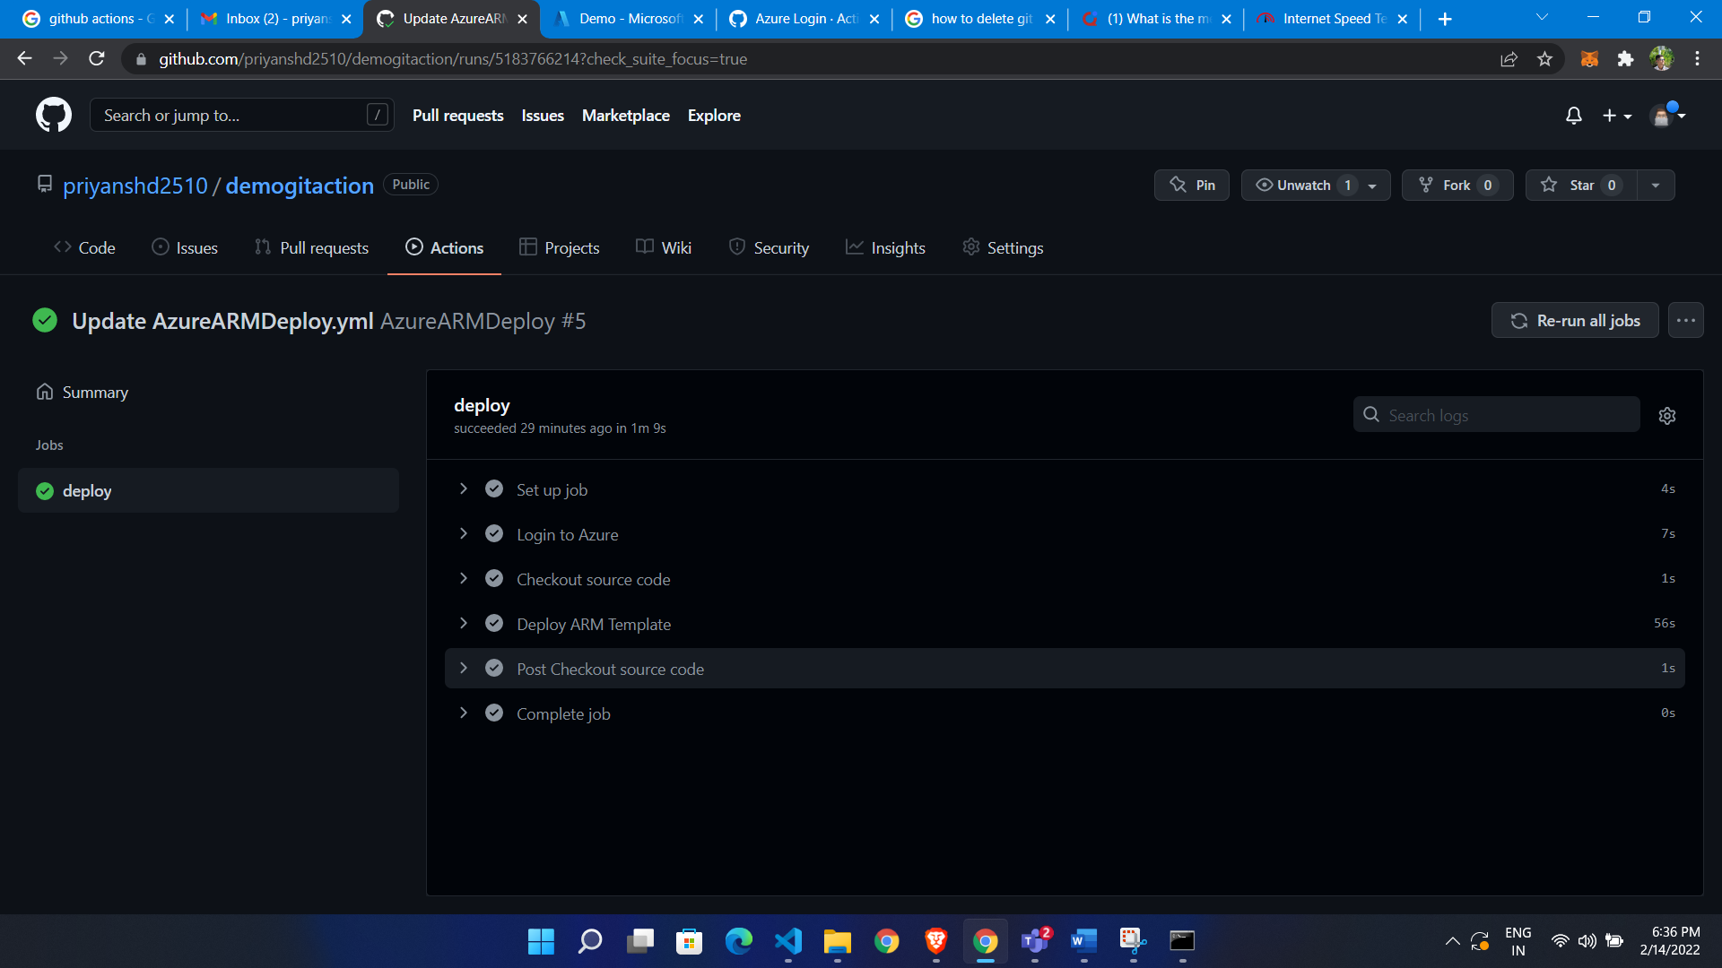

**It will deploy our storage account to azure**

